Onomatopoeia Poem – Poetry Assignment #2

CRASH! BANG! BOING! Did you know that sounds like these are not just noises, but a part of poetry?

What's That Sound?
Have you ever read a comic book? Maybe you've read about your favorite superhero defeating his or her archenemy, traveling to a far-off time or place, or solving a case with a group of detectives. At some point during the story, you probably encountered one or more words that the author used to describe a sound. In comics, oftentimes these appear in big, colorful spiky bubbles. They might say POW! when a villain takes a punch from a superhero, KABOOM! when an explosion happens, or WHIZ! when an airborne ninja star narrowly misses the hero's face.
These words are all examples of onomatopoeia. Onomatopoeia are words that are used to describe or mimic sounds. For example, describing the hissing and crackling of a fire is onomatopoeia because the words describe the sounds a fire makes. Often, these words are made-up specifically for the purpose of recreating a sound for the reader. Words like kaboom, pow, wham, pop, bong, slurp, and bang are common examples.
Onomatopoeia is a type of figurative language, or words and phrases that are used in a different way than usual to help the reader more deeply understand and relate to the writing. Movies, television shows, and music can use actual sounds and sound effects when telling a story that a viewer or listener can physically hear, while writers are unable to do so. Onomatopoeia uses regular words or made-up words to help the reader hear the sounds in the writing. It is essentially the sound effects for the written word!
An onomatopoeia poem is simply a poem that uses words which describe particular sounds throughout the poem. These poems can be short or long, and they can rhyme or not rhyme. Additionally, the words used as onomatopoeia can be real words or made-up. Many onomatopoeia poems involve certain familiar sounds such as water, fire, or wind, but they can be about any topic.

KABOOM...It Sounds Like A Poem
Look at this picture of fireworks. What words would you use to describe the sound of fireworks exploding in the air?
Some of the words that you might have thought about could be:
Bang!, Crash!, Whoosh!, Boom!, Pop!, Fizzle!, Kaboom!, Hiss!, Thunk!
Note: Onomatopoeic words are always punctuated with an exclamation point (!) right after the word.
Once you have created your list, you can now start to put the words into a logical arrangement using the onomatopoeia words to add sound for the reader.
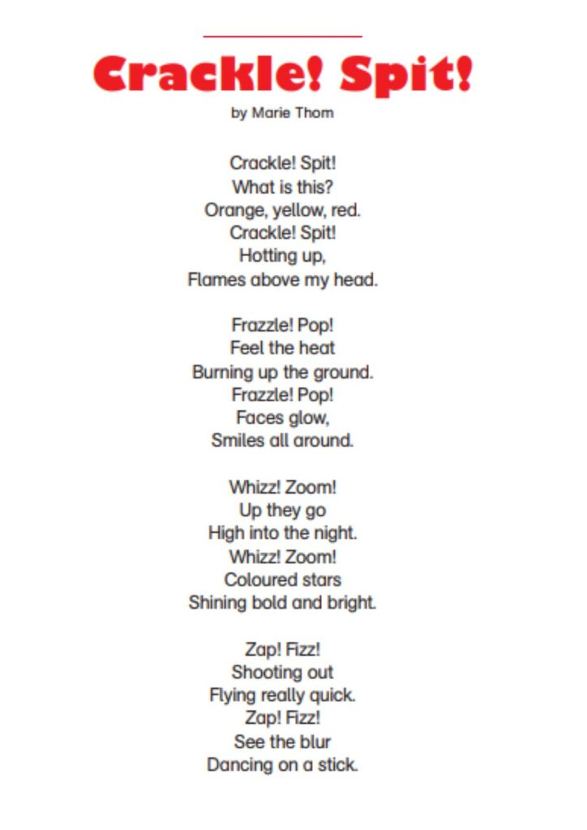
Assignment
- Your task is to create 1 onomatopoeia poem for your poetry anthology.
- Common topics for this type of poem are: sports, weather, nature,
animals, celebratory events (parades, parties, etc.)
- The poem needs to be a minimum of 10 lines and include at least 5 well placed uses of onomatopoeia (make sure to highlight each example to make it stand out).
- Avoid using too many onomatopoeia as this can become distracting to the reader
- The poem doesn’t have to rhyme, but you have the option if you would like to challenge yourself
- Optional Extension Opportunity – Place the poem inside a picture that represents an object associated with the topic of the poem (example – if the topic is the sport of baseball then type the poem inside of a baseball mitt)

