Limericks
Limericks were made famous by Edward Lear, a famous author who wrote the "Book of Nonsense" in the early 1800's. This was an entire book of silly limericks. From the title of this type of poem one might be mislead into thinking that limericks were first developed in Ireland - there is a county in Ireland named "Limerick" - however Limericks aren't Irish (Edward Lear was English).

A limerick is a “silly” poem with five lines. By “silly” I mean they are often funny or nonsensical, however they do manage to tell a short story in a limited amount of words. Due to their humorous nature, authors are permitted to exaggerate the words they use to rhyme (this is called Poetic Licence).
The traditional pattern of a Limerick makes them easy to read and gives them the feeling of a song. The five lines are arranged in the following rhyming scheme (a,a,b,b,a). In other words, the first, second and fifth lines rhyme with each other and have the same number of syllables (typically 8 or 9). The third and fourth lines rhyme with each other and have the same number of syllables (typically 5 or 6).
The first line of many Limericks start the same: “There once was a man/woman from (name of place)”
It is crucial in this form of poetry that you select a word for the end of the first line that is capable of rhyming with lots of other words. A website that can help you to identify words that rhyme can be found here: https://www.rhymezone.com/

Example of a (Funny) Limericks The Dog
A macho young swimmer named Dwyer, There once was a dog named Rorey,
Really liked playing with fire. Who went for a swim in the quarry.
One night in the dark He got all up tight
He swam with a shark, After getting a bite
And his voice is now two octaves higher. From a fish that was swimming to shorey.

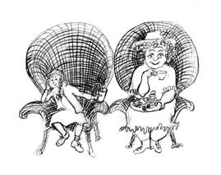

The Duchess
I sat next to the Duchess at tea.
It was just as I feared it would be.
Her rumblings abdominal
Were simply abominable
And everyone thought it was me.

Assignment: Create 2 Limericks.

