I Remember Poems

"I Remember" Poems allow an author to share cherished memories using their own unique voice. “I remember” poems were introduced by artist and writer Joe Brainard in his book, "I Remember"
(Granary Books, 2001).

They’re usually vivid, down to earth, and personal. They are free form in nature and thus are not constrained by syllable counts or rhyming schemes. They provide students with an avenue to explore personal feelings (both positive and negative) without having to concern themselves with rhyme or syllable counts.

I Remember poems bring to mind not only the emotions you felt at the time, but numerous sensory details and an idea of what the experience means to you today.

Directions for writing this type of poem:
Brainstorm
Recall: one thing that happened this week, one thing that happened last month, one thing that happened 2 to 3 years ago and one thing that you have good memories about–a time, a place, an event

Select one of these memories.
Write about this memory. Every line can begin with “I remember”, but this can become a little too repetitive. I suggest starting each new idea in the memory (about every 2-3 lines) with ‘I remember’.

For example: My First Homerun

I remember walking up to the plate with that familiar knot in my stomach;
My surprise when the bat connected with the ball;
Watching the ball sail through the air;

I remember the roar of the crowd as I rounded second base;
My heart pounding as the coach waved me past third;
The thrill of my foot touching home base;

I remember being swarmed by my teammates;
Slaps on the back;

I remember leaving the park that day with my head held high,
Wanting to hold onto to that feeling for the rest of my life.
I remember …

Assignment
- Complete one “I Remember” poem.
- It may be written in free verse form or rhyme.
- Must be a minimum of 15 lines
- Pictures to enhance the memory may be added.

I Remember… Mending a Broken Heart
I remember the day of my father’s heart attack.

I remember his insistence on a steady meat and potato diet; his loathing of exercise; his consumption of a pack 20 cigarettes a day.
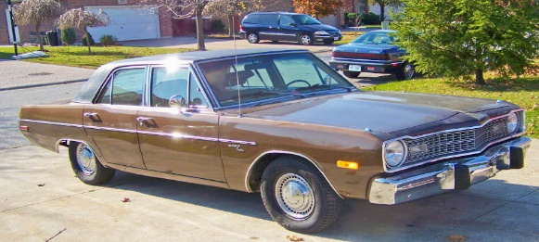
I remember departing the school late bus after basketball practice. My fourteen year old sister greeting me at the door sobbing, “We have to get to the emergency room! Now!”

I remember driving the used brown Dodge Dart dad had recently purchased. Intended to be the “kid’s car.” It now felt more like a hearse driving us to our father’s funeral.

I remember my mother sitting bedside, stroking his hand. A strange mixture of passion and despair blended intricately together like a muddled Rubric’s Cube.

I remember the irritating rhythm of the live support machine’s in the room working in unison to retain his damaged pulse and fleeting spirit. BEEP! BEEP! BEEP! BEEP!
I remember the hospital smells. The overpowering stench of disinfectant. The unmistakable aroma of death in the air in stark contradiction to the faint dash of hope inhaled by the patients loved ones.

I remember placing a hand on my father’s once proud shoulders. The same strong shoulders he used to lug me during the Santa Clause Parade, and the same shoulders that carried the weight of my family’s finances. These same shoulders now seemed fragile and terrified. It donned on me that in this instant I was being called upon to assume his role.

I remember embracing my mother in an attempt to relieve her trepidation at the exact moment I concentrated on what doctor reported. Holding onto her as tightly as I hung onto every word the physician uttered.

I remember the alleviation in the room upon hearing that his condition was reparable.

I remember happiness and peace, but most of all love.

I remember …

