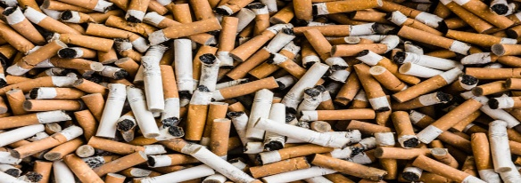
I Remember… Mending a Broken Heart
I remember the day of my father’s heart attack.

I remember his insistence on a steady meat and potato diet; his loathing of exercise; his consumption of a pack 20 cigarettes a day.
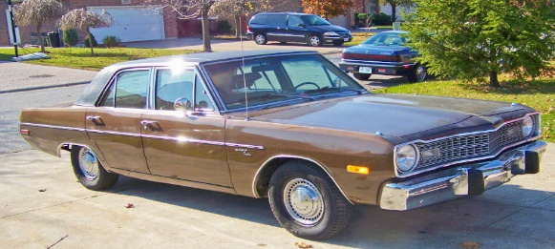
I remember departing the school late bus after basketball practice. My fourteen year old sister greeting me at the door sobbing, “We have to get to the emergency room! Now!”

I remember driving the used brown Dodge Dart dad had recently purchased. Intended to be the “kid’s car.” It now felt more like a hearse driving us to our father’s funeral.

I remember my mother sitting bedside, stroking his hand. A strange mixture of passion and despair blended intricately together like a muddled Rubric’s Cube.

I remember the irritating rhythm of the live support machine’s in the room working in unison to retain his damaged pulse and fleeting spirit. BEEP! BEEP! BEEP! BEEP!
I remember the hospital smells. The overpowering stench of disinfectant. The unmistakable aroma of death in the air in stark contradiction to the faint dash of hope inhaled by the patients loved ones.

I remember placing a hand on my father’s once proud shoulders. The same strong shoulders he used to lug me during the Santa Clause Parade, and the same shoulders that carried the weight of my family’s finances. These same shoulders now seemed fragile and terrified. It donned on me that in this instant I was being called upon to assume his role.

I remember embracing my mother in an attempt to relieve her trepidation at the exact moment I concentrated on what doctor reported. Holding onto her as tightly as I hung onto every word the physician uttered.

I remember the alleviation in the room upon hearing that his condition was reparable.

I remember happiness and peace, but most of all love.

I remember …

