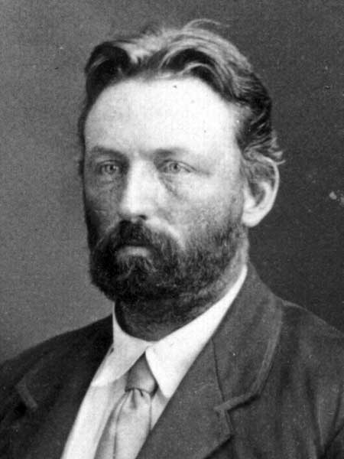
Continuing Conflict and the Founding of Manitoba
Not everyone supported Riel and the National Committee of the Metis. A few recent Red River Settlers from _____________, led by Doctor ______ ___________ (see picture to the right), wanted the Canadian government to take over the West immediately. They were known as the Canadians.

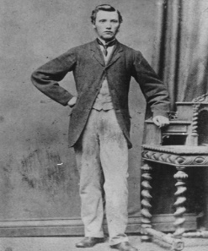
On December 7th of 1869, Louis Riel and ________ men surrounded Schultz’s store. They took __________ prisoners (including Schultz and a labourer named _________ ___________ (see picture to the left).

The next day Riel and his supporters set up a ______________ government. This temporary government’s purpose was to _____________ terms for joining the Canadian Confederation.
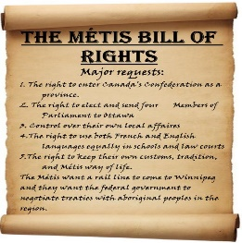
The Metis drafted a document called “The Metis Bill of Rights” that required the Canadian government to fulfill three requests in order for the Metis to surrender the Red River territory peacefully:
a) _______________________________________________________
b) _______________________________________________________
c) _______________________________________________________

As negotiations progressed, prisoner __________ ___________ escaped from Fort Garry. He was known as a “_____________ and ___________________” individual. He was a Protestant who had strong anti-____________, anti-______________ feelings and he directed these toward Riel and his supporters.
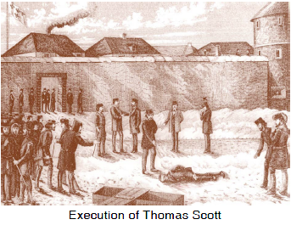
On February 17, 1870, Thomas Scott was recaptured and put back in ______________. He continued to verbally abuse the guards and threatened to kill ________ ___________. The guards demanded that Scott be ________ _____________ (bring to trial for his offences). On March 4th, he was taken before a firing squad and _____________.

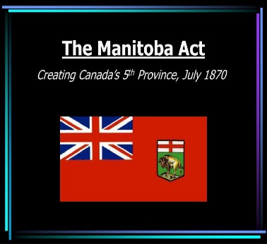
Many Ontario residents demanded that Riel and his followers be ________________. Many Quebec citizens were ________________ toward the Metis and their cause. On May 21st, 1870 a force of _________ easterners set out for Fort Garry to restore order there, find Louis Riel and _____________ Scott’s death.

Negotiations continued between the Metis and the Canadian government and an agreement was reached. On July 15, 1870 the ____________ _______ was signed and the fifth province of Canada was created. On August 24th the Red River Expedition arrived at Fort Garry with the intention of capturing Louis Riel, but he had ______.

*** Compare the Metis Bill of Rights with the terms of the Manitoba Act. Discuss similarities and differences. How much of what the Metis wanted did they actually get? ***

