Taking the West

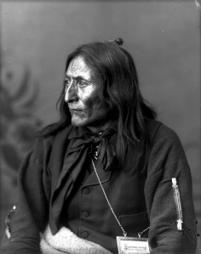
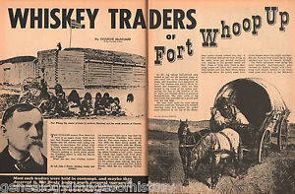
- When the first whites arrived from Montana (USA) the traded ________________, ______________, and _______________ for buffalo robes. Soon the whites traded an awful concoction of _________________.
“The whiskey brought among us by the traders is fast killing us off. We are powerless before this evil. We are unable to resist the temptation to drink when brought in contact with the white man’s water. Our houses, buffalo robes and other articles of trade go for whisky.” Quote from ____________________ - Chief of the Blackfoot (see picture to the left)

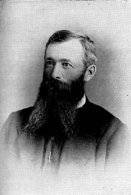
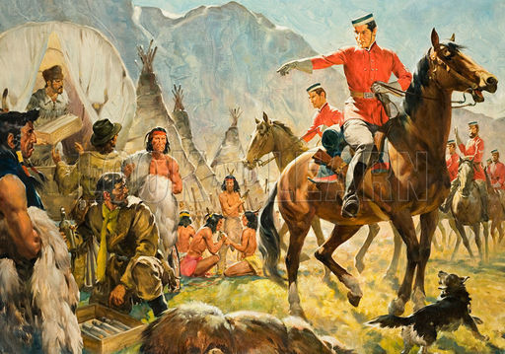
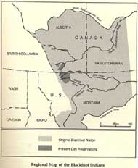
- By the early 1870’s a dozen _____________ trading forts were built on Blackfoot territory (see map to left). John A. MacDonald was alarmed by reports of illegal American whisky traders streaming into the North West. He orders ____________ men of the newly formed ________________ to march west and gain control of the area. He intends to keep the Americans out of the North West.

- As well, MacDonald sends a Methodist missionary, John McDougall (see picture to right) to assure the Crowfoot that the police come as _________________, and all __________________ ___________________ and __________ __________ will stop.
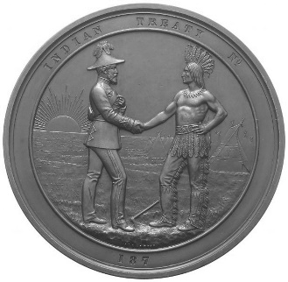
- Although the Crowfoot are weakened by alcohol, the Blackfoot remain a powerful ____________ force. Crowfoot _______________ the “hand of friendship” from the Canadians.
“My brothers, your words make me glad. We want _______________. What you tell us about this strong power that is covered with food law and will treat the Indian the same as the white man makes us glad to hear. My brother I believe you and are thankful.”
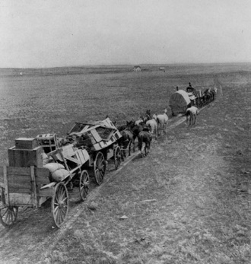
- The whiskey traders are chased back to Montana by the _______________. The arrival of the police is the first step in an ambitious plan to populate the West with ________________ settlers. Soon the first settlers start to arrive.

